UNIT II: Data Warehouse and Data Preprocessing
Data Preprocessing is a critical step in the data analysis pipeline that involves cleaning, transforming, and organizing raw data into a suitable format for analysis or modelling. Raw data is often incomplete, inconsistent, noisy, and contains errors, pre-processing improves data quality and ensures that subsequent steps such as data mining, machine learning, or statistical analysis are effective and accurate.

Problem Associated with Data Processing?
- Data Quality Issues:
- Missing Data or incomplete records can bias analysis or reduce accuracy.
- Noisy Data: errors, inconsistencies, or random variations (noise).
- Incorrect Data: due to manual errors, faulty sensors, or data corruption.
- Data comes from heterogeneous sources with different formats, units, or representations, causing conflicts and difficulties in integrating datasets.
- Duplicate data can increase storage costs, processing time, and skew analysis.
- Datasets with many features can be computationally expensive and may lead to over fitting in models if irrelevant or redundant features are present.
- Unstructured data requires specialised processing.
- Big Data demand high computational resources and efficient algorithms for processing within reasonable time.
- Sensitive data requires secure processing to protect privacy with regulations.

Data Preprocessing Techniques
- Data Cleaning
- Handling Missing Values: Methods include removing records, imputing with mean/median/mode, or using predictive models.
- Noise Removal: Techniques such as smoothing, binning, regression, or clustering to reduce random errors.
- Outlier Detection and Removal using statistics or domain knowledge.
- Resolving data conflicts, redundancies, and inconsistencies during Integration.
- Data Transformation
- Normalization: Scaling data to a specific range e.g. [0, 1] to avoid bias in algorithms sensitive to data magnitude.
- Standardization: Rescaling data to have zero mean and unit variance.
- Aggregation: e.g., monthly sales from daily data.
- Feature Construction from existing data to enhance model performance.
- Data Reduction without significant loss of information to improve processing speed and reduce storage. Techniques include dimensionality reduction (PCA), attribute subset selection, data sampling, and numerosity reduction.
- Data Discretization: Converting continuous data into discrete intervals or categories, this can simplify modelling and improve interpretability.
- Data Encoding: Converting categorical variables into numerical format using techniques like one-hot encoding, label encoding, or binary encoding.

Need and Importance of Data Preprocessing: Raw data is often incomplete, inconsistent, and noisy, which can adversely affect the quality of analysis and models. Some key points are: Improving Data Quality, Enhancing Model Accuracy, Reducing Complexity, Facilitating Data Integration, Enabling Meaningful Analysis, Avoiding Bias,Saving Time and Resources.

Data Warehouse is centralized repository that stores integrated data from multiple heterogeneous sources. It is designed to support business intelligence (BI) activities, such as reporting, analysis, and decision-making. Data warehouses store historical and current data in a format optimized for querying and analysis rather than transaction processing.
Characteristics of Data Warehouse:
- Subject-oriented: key subjects like sales, customers, products.
- Integrated: Data from different sources are cleaned and integrated.
- Non-volatile: Data is stable and does not change frequently.
- Time-variant: Stores historical data for trend analysis.

Advantages of Data Warehouse:
- Improved Decision Making.
- Data Integration.
- Historical Intelligence allowing trend analysis over time.
- Optimised for read operations with indexing and pre-aggregated data.
- Consistent Data Quality.
- Support for Business Intelligence Tools: Facilitates use of dashboards, reporting tools, and OLAP.

Disadvantages of Data Warehouse:
- High Cost, significant investment in HW/SW, skilled personnel.
- Data integration, cleaning, transformation are hard and time-consuming.
- Data Latency: Since data is loaded periodically, real-time may not be available.
- Continuous updating, monitoring, managing to remain relevant.
- With rapid growth, scaling a traditional DW can be challenging.

Data Lake is a centralized repository that stores raw data in native format, including structured, semi-structured, and unstructured data. Unlike data warehouse, it doesn’t enforce schema at time of data ingestion (schema-on-read).
Characteristics: Stores large volumes of diverse data types, Highly scalable and flexible, Supports big data analytics and machine learning
Example: An organization collects logs from web servers, social media feeds, sensor data, and customer transactions into a data lake like Amazon S3 or Hadoop HDFS. Data scientists later process and analyse this raw data.

Data Mart is a subset of a data warehouse, focused on a specific business line, department, or subject area. It contains a portion of the organization’s data tailored to the needs of a particular group.
Characteristics: Smaller and more focused than data warehouses, Improves query performance for specific departments, Can be dependent (sourced from a data warehouse) or independent
Example: A retail company’s sales data mart contains data related only to sales transactions, allowing the sales team to generate reports and analyse performance without accessing the full data warehouse.

Fact Table is the central table in a star or snowflake schema of a data warehouse. It stores quantitative data (measures or metrics) for analysis, such as sales amounts, quantities, or counts.
Characteristics: Contains foreign keys referencing dimension tables, Stores numerical performance data, Large in size compared to dimension tables
Example: In a sales data warehouse, the fact table might record sales transactions with measures like Sales, Amount, Units Sold, and foreign keys to dimensions such as Product_ID, Time_ID, and Store_ID.

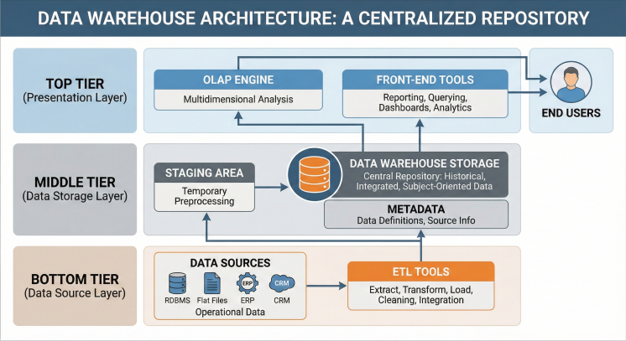

Component | Explanation
Data Sources | External/internal systems providing operational data (e.g., sales, CRM, ERP systems).
ETL Tools | Extract, Transform, Load – helps in data cleaning, integration, and loading into the data warehouse.
Staging Area | Temporary location used for data preprocessing before loading into the warehouse.
Data Warehouse Storage | Central repository that stores historical, integrated, and subject-oriented data.
Metadata | Stores information about the data like source, transformation rules, and data definitions.
OLAP Engine | Enables multidimensional analysis (e.g., slicing, dicing, drilling).
Front-End Tools | Used by end users for reporting, querying, dashboards, and analytics.

